In this investigation a process for measuring the relationship between two variables is examined. The measure is called the q-correlation coefficient.
To calculate the q-correlation coefficient
- Plot a scatter graph for the two variables.
- Determine the median for the values on the horizontal (x) axis.
- Determine the median for the values on the vertical (y) axis.
- Divide the region where the points occur into 4 quadrants by
  - Drawing a vertical line where x = median of values on the horizontal axis
  - Drawing a horizontal line where y = median of values on the vertical axis
- Label the quadrants e.g. A, B, C and D in the positions as shown on the graph below. The top right quadrant is always A, the top left is B, bottom left is C and bottom right is D.
- Count the points in each quadrant (do not count points on the dividing lines).
- Use the rule q-correlation coefficient = $\frac{\left(a+c\right)- (b+d)}{a+b+c+d}$ where a represents the number of points in quadrant A, b represents the number of points in quadrant B, c represents the number of points in quadrant C, and d represents the number of points in quadrant D.

Example: M1 and M2 represent the scores of ten students in two mental Maths tests.

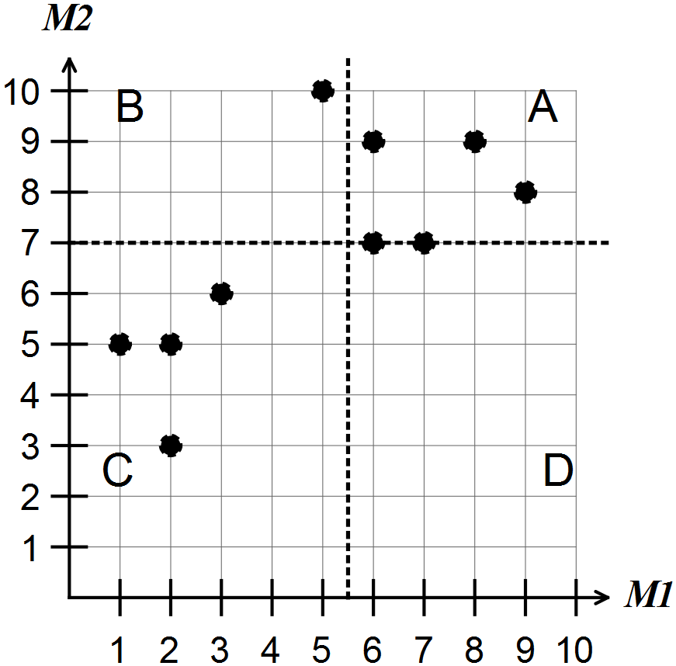

For the scatter graph shown above
- the median of M1 is 5.5
- the median of M2 is 7
- there are 3 points in A so a = 3. Similarly b = 1, c = 4, d = 0.
The points (6,7) and (7,7) are on a line and not counted in any quadrants.
Hence, the q-correlation coefficient is equal to
Note: Give q-correlations as fractions and decimals.

